**MOCK API:**

1) install json-server using command: **npm install -g** [**json-server@0.17.0**](mailto:json-server@0.17.0)

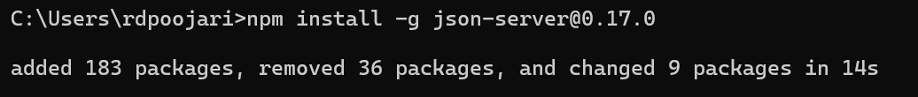

2) create a file db.json in the project folder and store your mock data in this format:  
{

“endpoint_name_1”: <response>,

“endpoint_name_2”: <response>

}

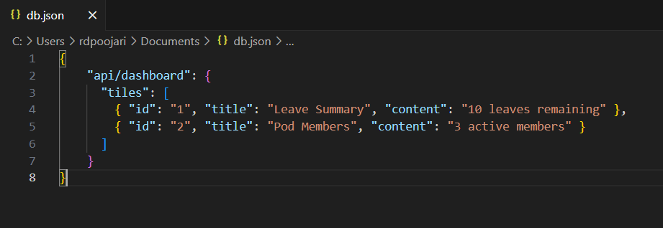

3) start the server using command: json-server --watch "path to db.json"

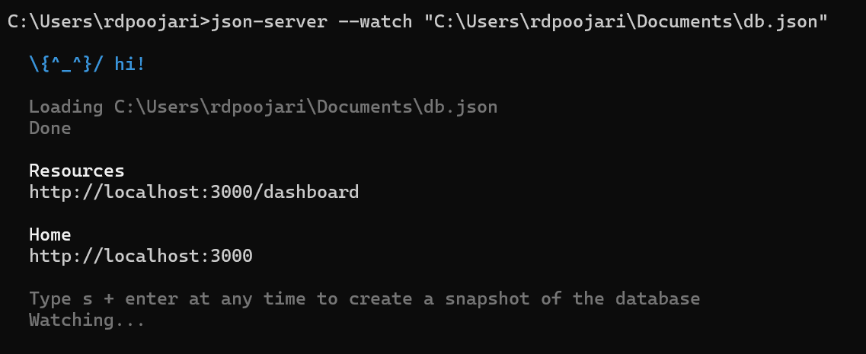

4) Hit the API to get response:  
